|  |  |  |  |  |  |  |
| --- | --- | --- | --- | --- | --- | --- |
| VILNIAUS KOLEGIJA  UNIVERSITY OF APPLIED SCIENCES  FACULTY OF ELECTRONICS AND INFORMATICS  Image result for viko logo | | |  | | | VILNIUS COLLEGE  Image result for viko logoFACULTY OF ELECTRONICS AND INFORMATICS |
|  | | |  | | |  |
| **BUSINESS MANAGEMENT SYSTEMS** | | |  | | | **INTRODUCTION TO INFORMATICS** |
| PRACTICAL ASSIGNMENT  PRACTICE WORK NO.2  6531BX028 PI18E | | |  | | | PRACTICAL ASSIGNMENT  SPOTIFY USER MANUAL  6531BX028 PI18E |
| STUDENT | DŽIUGAS PEČIULEVIČIUS | STUDENT | | DŽIUGAS PEČIULEVIČIUS |
| (SIGNATURE)  5/10/2020 | | |  | | | LECTURER |
| LECTURER | TATJANA LIOGIENĖ | (SIGNATURE)  10/17/2018 | | VIRGILIJUS KUKLIERIUS |
| (SIGNATURE)  5/10/2020 | | |  | | | 2018 |

2020

**TABLE OF CONTENTS**

INTRODUCTION 4

1. ORGANIZATION 5

2. MODULES OFFERED TO THE ORGANIZATION 7

3. MODULES FUNCTIONALITY 8

4. ODOO CONFIGURATION 19

CONCLUSIONS 20

**TABLE OF FIGURES**

Figure 1- 0 level DFD diagram 5

Figure 9- Inventory Management module 8

Figure 10 - All existing products 8

Figure 11 - Product categories 9

Figure 12 - Invoicing Management module 9

Figure 13 - Order description 9

Figure 14 - Invoice creation pt.1 10

Figure 15 - Invoice creation pt. 2 11

Figure 16 - Invoice validation 12

Figure 17 - Sending the Invoice pt1 13

Figure 18 - Sending the Invoice pt2 13

Figure 19 - Invoice example 14

Figure 20 - Manufacturing module 15

Figure 21 - Choose a product we want to manufacture 15

Figure 22 - Select the quantity how many items are needed. 15

Figure 23 - Confirm production 16

Figure 24 - Mark as Done after finishing the order 16

Figure 25 - We can see all our previously made orders 16

Figure 26 - Sales management 17

Figure 27 - Sales dashboard 17

Figure 28 - Email marketing module 18

Figure 29 - Newsletter signup 18

# INTRODUCTION

**Program used for charts**

Website: odoo.com

**Goal**

Our goal is to choose necessary ODOO modules for select company and configure them.

**Requirements**

* Title sheet;
* Content;
* Introduction (purpose of the work and tasks to achieve it (steps of pw2));
* Organization (Presentation of the organization with its activities (services, products); Zero-level DFD with description);
* Suggested ODOO modules (name of module and justification why it is offered to this organization);
* Detailed description of modules (demonstrating modules with sample data, pictures, description);
* Conclusions.

# ORGANIZATION

This work is about a small watch company which is really passionate about their work whose goals are to make watches affordable to everyone. This company would sell watches, watch straps and replacement items, and other accessories like eyewear and jewelry. Company would also offer replacements for defected items that have been bought online. Just like in last semester we talked how the company process is managed.

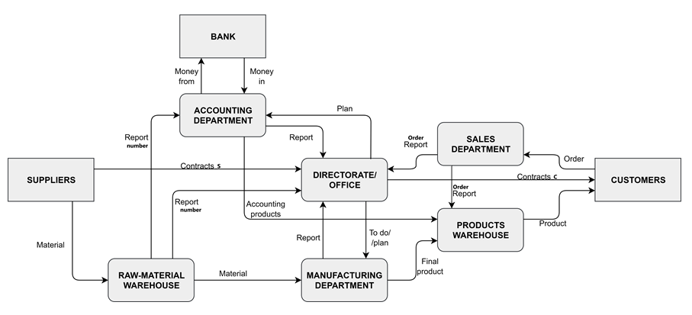

Figure 1- 0 level DFD diagram

|  |  |
| --- | --- |
| **Process name** | **Process description** |
| ACCOUNTING | Managing company’s money. Takes it into and out of the bank. Accounting department provides office a report on how company is doing money-wise and other similar statistics.  Accounting department also takes a plan from office on what to do and report from raw-material warehouse on number of things it is stored. |
| DIRECTORATE / OFFICE | This basically is a core of a company. All managers and shareholders are here.  Office provides contracts to customers when they buy something. They also provide a plans on what to do to manufacturing and accounting departments. Office also provides suppliers with a plan on ordered things and what is needed to be sent to raw-material warehouse They take in reports form all the departments of a company. |
| RAW-MATERIAL WAREHOUSE | Warehouse where all material necessary is stored. Material is gathered from a supplier.  When needed – necessary material is transported to manufacturing department and a report is then sent to an accounting department and an office. |
| MANUFACTURING DEPARTMENT | In this department all items are assembled and when “ready to be sold”, then they are transported to product warehouse. Then a report is sent to an office. Manufacturing department takes material from raw-material warehouse and reports office about it. |
| PRODUCT WAREHOUSE | Product warehouse is where all final products ready to be sold are stored. It can be parts of computers or it can also be assembled computers from manufacturing department. Product warehouse is managed by accounting department. All products from warehouse are sent to a customer. |
| SALES DEPARTMENT | Sales department gets a number of things customers have ordered and that number of sales report goes to the office. |

# MODULES OFFERED TO THE ORGANIZATION

Table 1 - ODOO modules

|  |  |  |
| --- | --- | --- |
| **Process of organization (DFD)** | **ODOO module** | **Comment** |
| ACCOUNTING | Invoicing management | Helps us organize invoices. We can also manage company data. |
| RAW-MATERIAL WAREHOUSE  /  MANUFACTURING DEPARTMENT | Manufacturing | We track orders and the quantity of items that need to be produced. Basically helps us manage necessary material. |
| PRODUCT WAREHOUSE | Inventory management  eCommerce | Product warehouse is where all final products ready to be sold are stored. Inventory management module helps our shop to keep track of our inventory and create products and their categories. |
| SALES DEPARTMENT | Sales management | Sales department gets a number of things customers have ordered and that number of sales report goes to the office. |

# MODULES FUNCTIONALITY

**Inventory management**

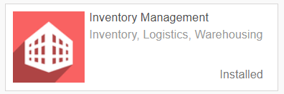

Figure 2- Inventory Management module

As mentioned above Inventory management module helps our shop to keep track of our inventory and create products and their categories.

One of the features of this module is that we can keep track of our products, edit them and create new ones.

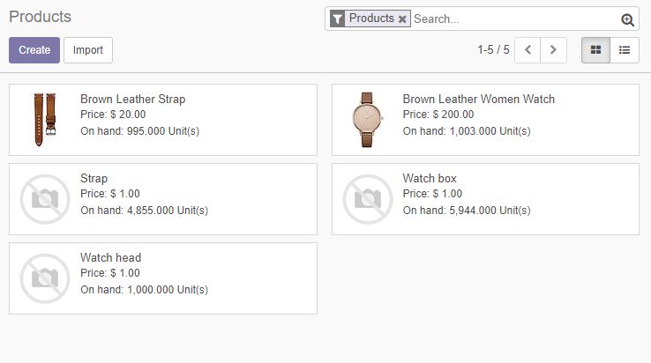

Figure 3 - All existing products

Another feature of this module is that it lets us to create categories and subcategories for our products, which makes user interference and search for specific products a lot simpler.

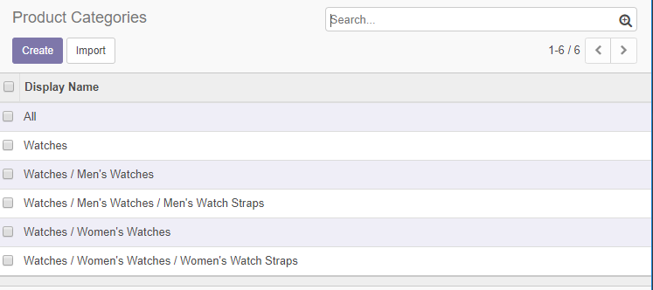

Figure 4 - Product categories

**Invoicing Management**

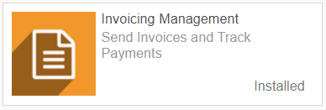

Figure 5 - Invoicing Management module

Invoicing management module helps us create professional looking invoices and send them to our customers.

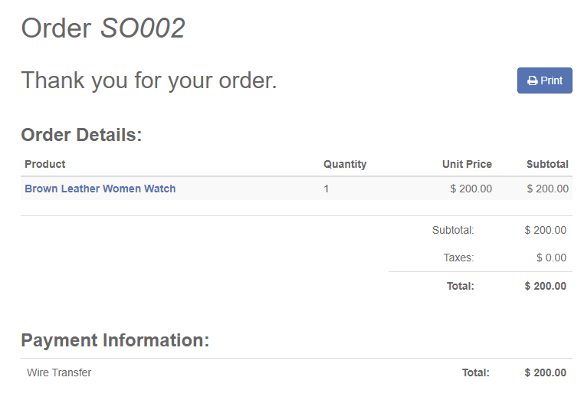

Figure 6 - Order description

When someone makes an order we will want to check the order first.

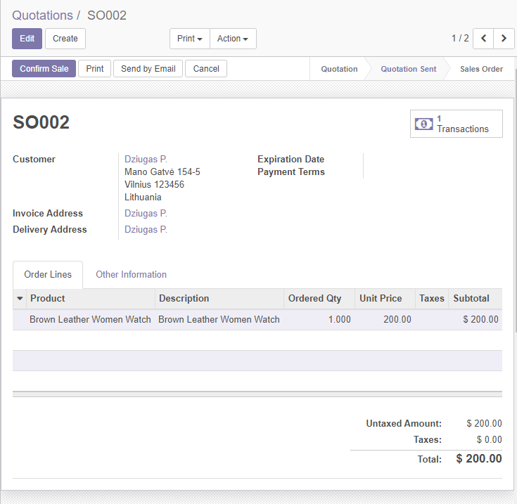

Figure 7 - Invoice creation pt.1

After confirming the order, we can now create an invoice.

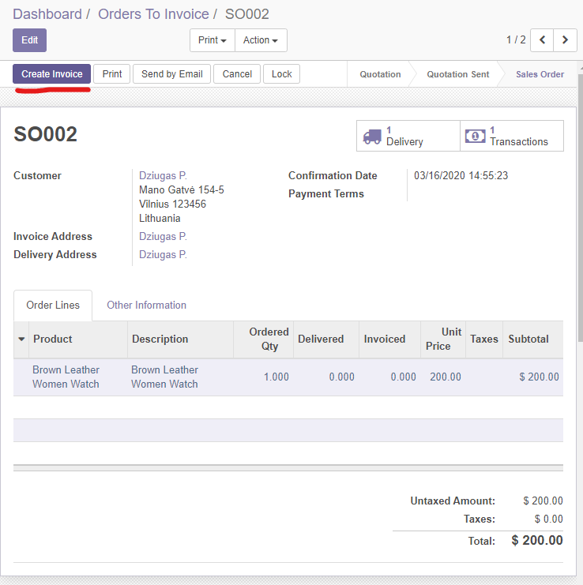

Figure 8 - Invoice creation pt. 2

When we created the invoice we want to validate it.

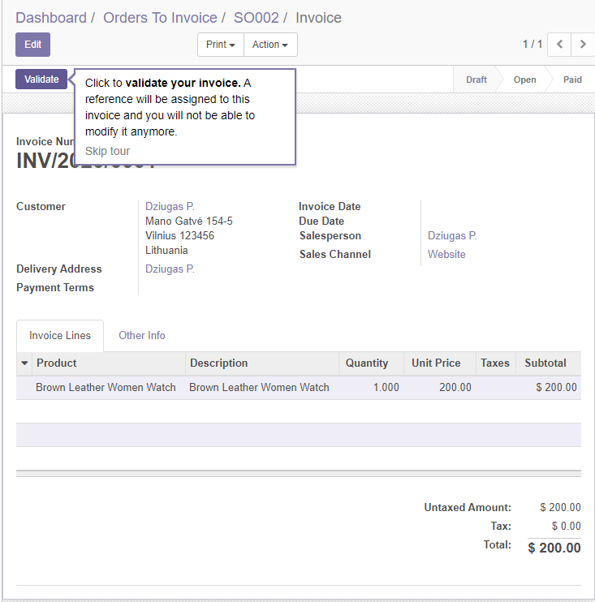

Figure 9 - Invoice validation

After validating the invoice, we will now be able to send the invoice to the customer.

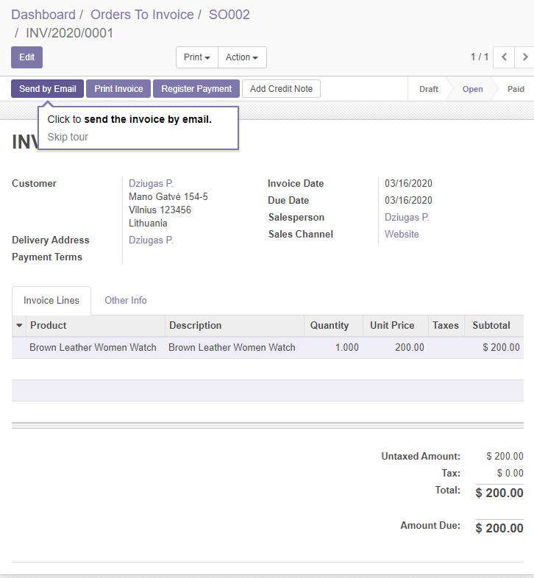

Figure 10 - Sending the Invoice pt1

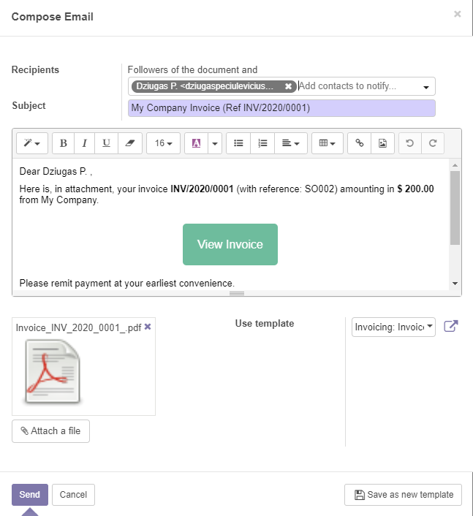

Figure 11 - Sending the Invoice pt2

After clicking the send button the customer should receive the invoice looking something similar to something like this below:

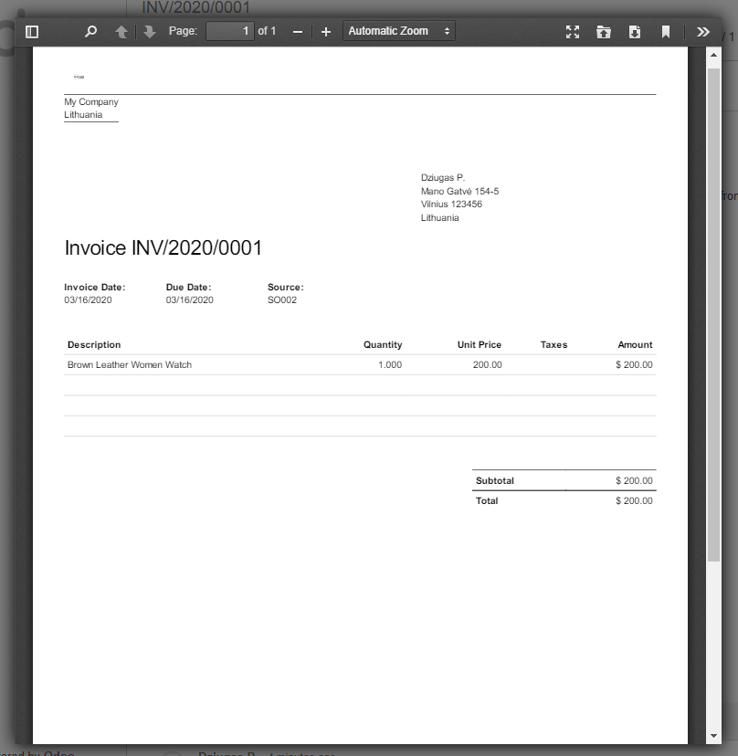

Figure 12 - Invoice example

**Manufacturing**

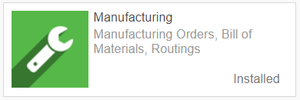

Figure 13 - Manufacturing module

Manufacturing module helps our business to keep track of orders and the quantity of items that need to be produced.

In the example we see a way how we can make manufacturing orders to make new products for our inventory.

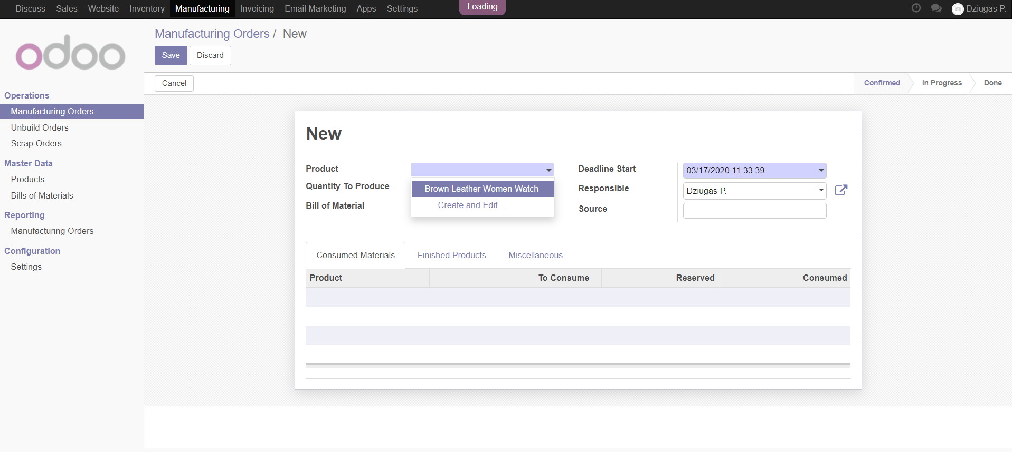

Figure 14 - Choose a product we want to manufacture

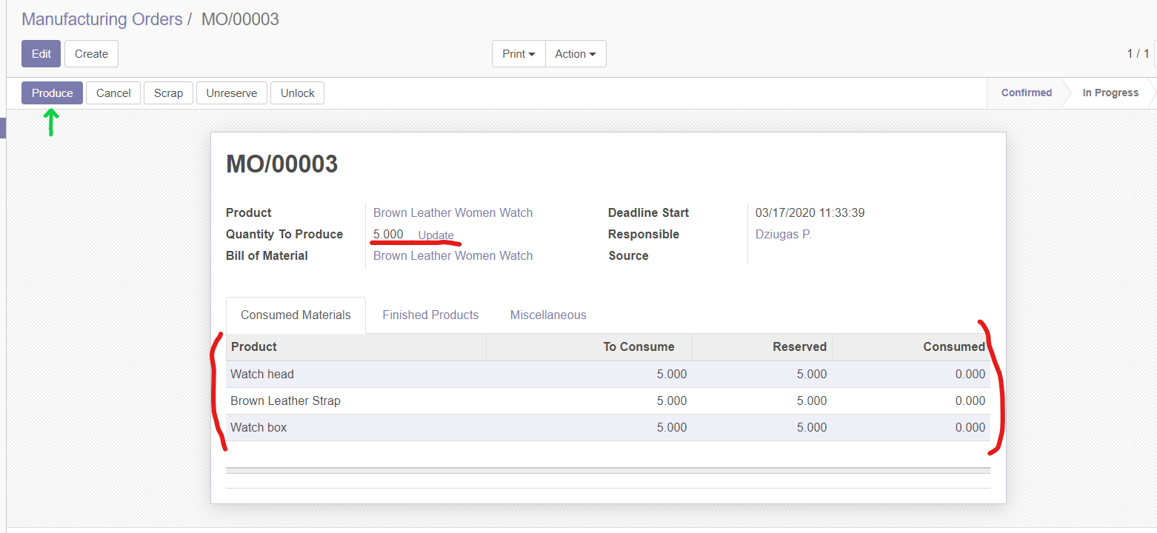

Figure 15 - Select the quantity how many items are needed.

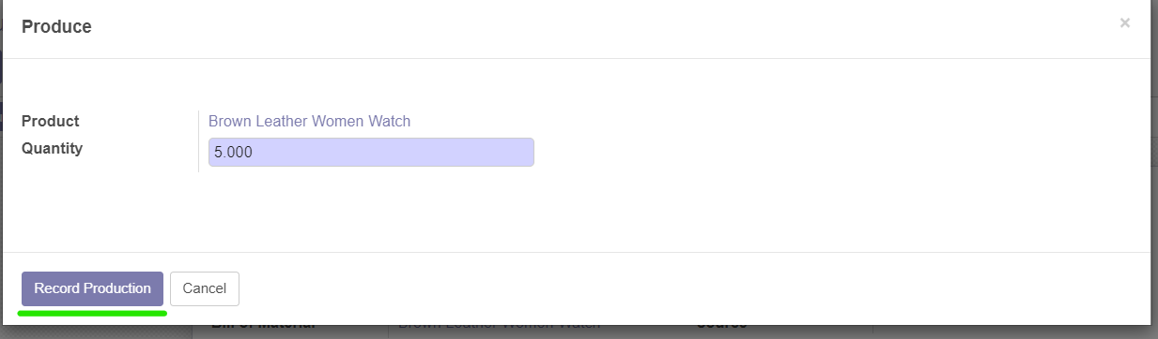

Figure 16 - Confirm production

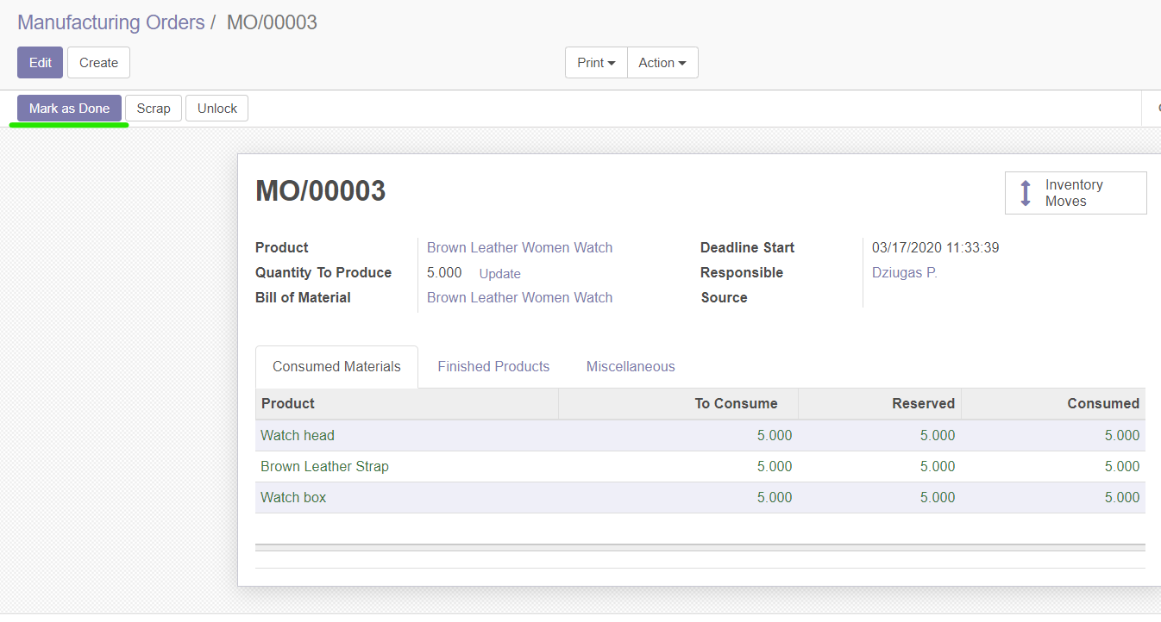

Figure 17 - Mark as Done after finishing the order

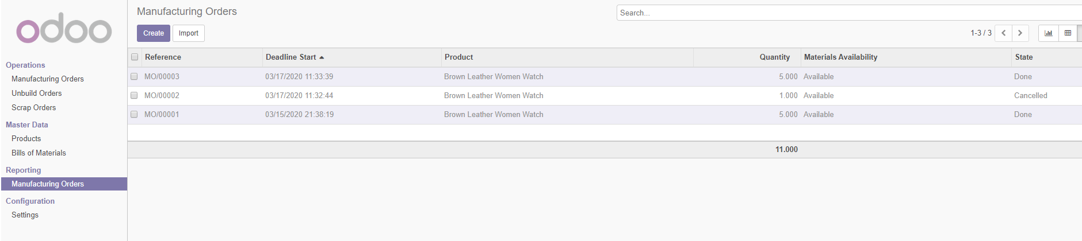

Figure 18 - We can see all our previously made orders

**Sales Management**

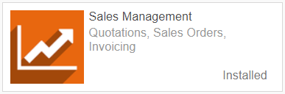

Figure 19 - Sales management

Sales management module helps us to keep track of orders that have been made and send abandoned cart emails. We can see abandoned carts and send recovery emails to our users which brings the conversion rate up. Sales management module basically helps us manage orders, send invoices, and recover abandoned carts.

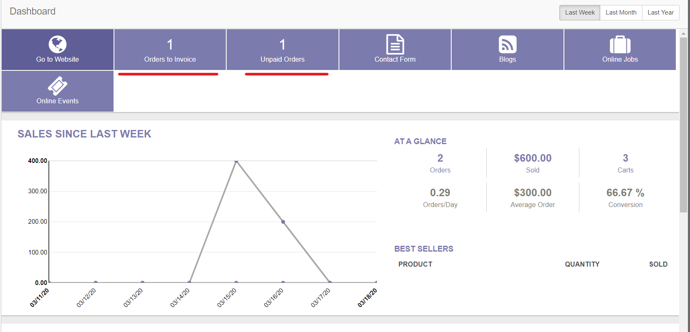

Figure 20 - Sales dashboard

**Email Marketing**

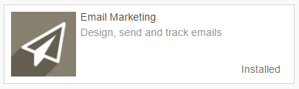

Figure 21 - Email marketing module

Email marketing solution. Helps us grow the base of existing customers with marketing emails.

Basically we can offer people some benefits for subscribing to our newsletter. Once they subscribe we will have another way of reaching our customers and send subscribers our marketing emails for free!

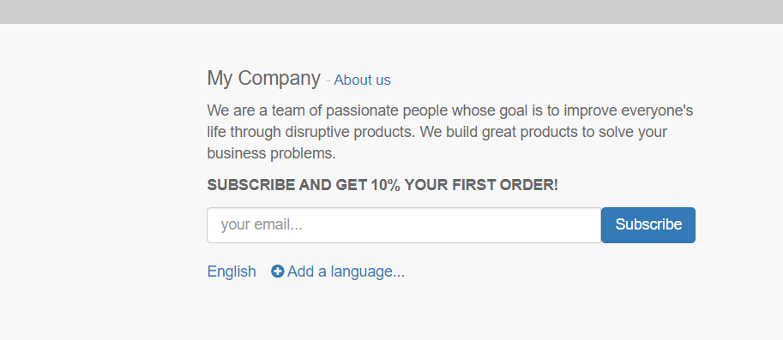

Figure 22 - Newsletter signup

# ODOO CONFIGURATION

Table 2 - modules configuration

|  |  |  |
| --- | --- | --- |
| **ODOO module** | **What is configured** | **Comment** |
| SETTINGS | We can set the system language to Lithuanian or any other from a list | We can now allow user to select a preferred language for the system  [pictures] |
| Invoicing management | Setting currencies currency between Euros and Dollars. | Allowing users to change their currencies according on where they live  [pictures ] |
| SETTINGS | Applying rules to users, so we can limit the usage for some users who are not administrators. Basically we are limiting their ability to do anything that a normal user shouldn’t be able to do. | Applying rules for better security in the system.  [pictures ] |

## **Setting a system language**

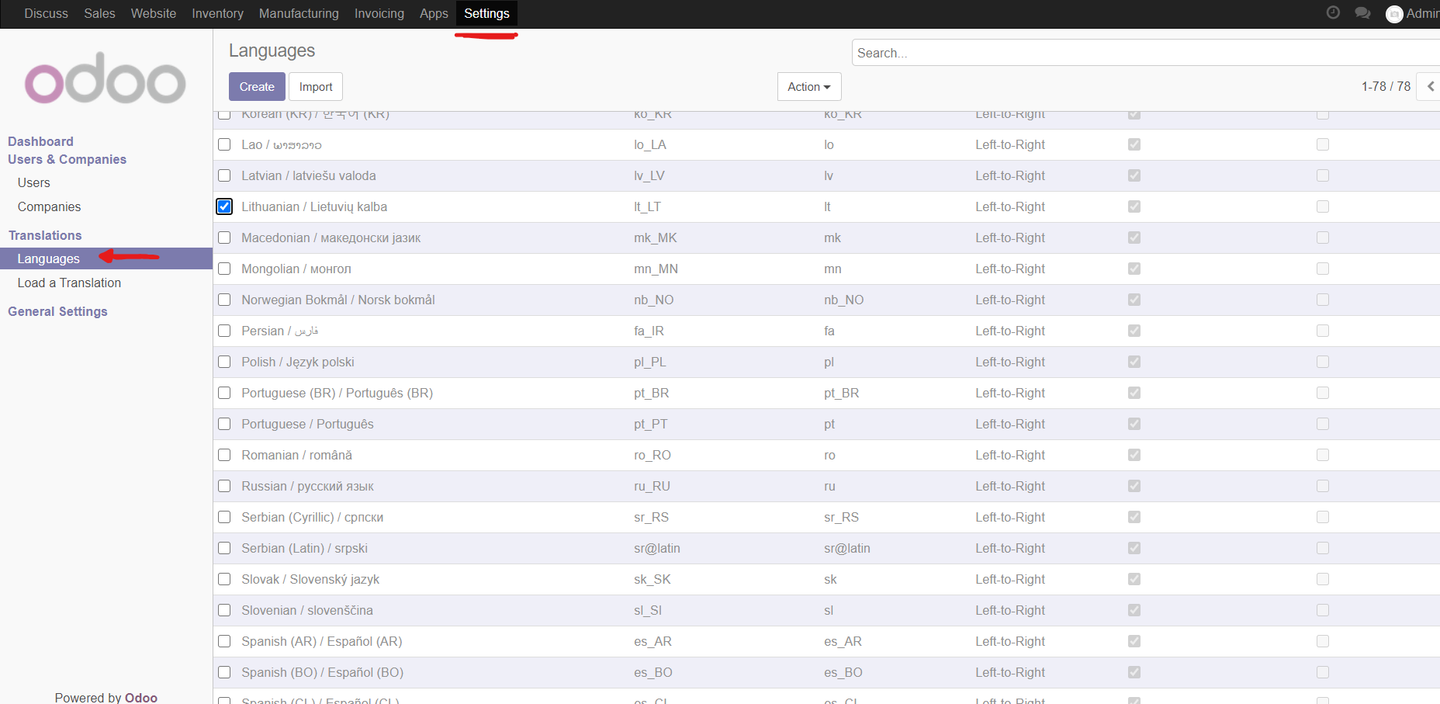

Figure 30 - Languages

To change a system language, we need to go to setting and languages. And then we want to select our preferred languages and confirm.

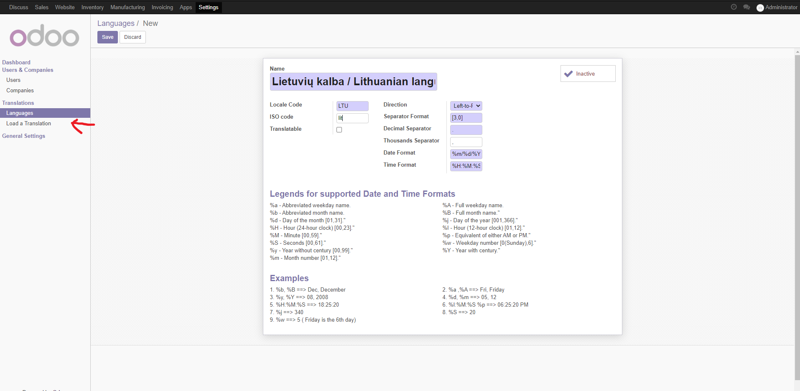

Figure 31 - Adding new languages

After selecting our languages, we want to load it.

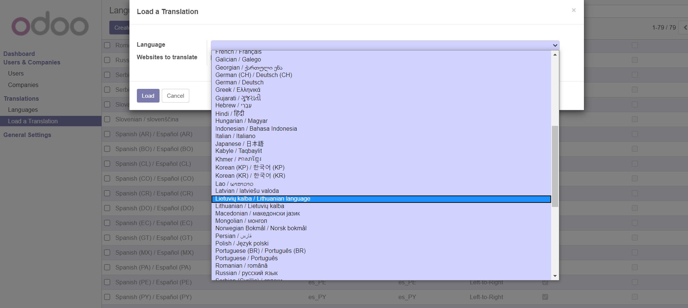

Figure 32 - Selecting language

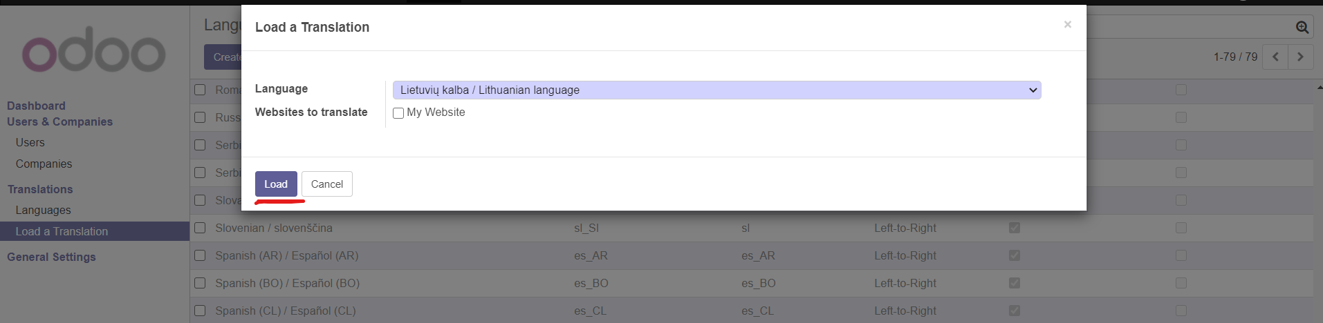

Figure 33 - Loading languages

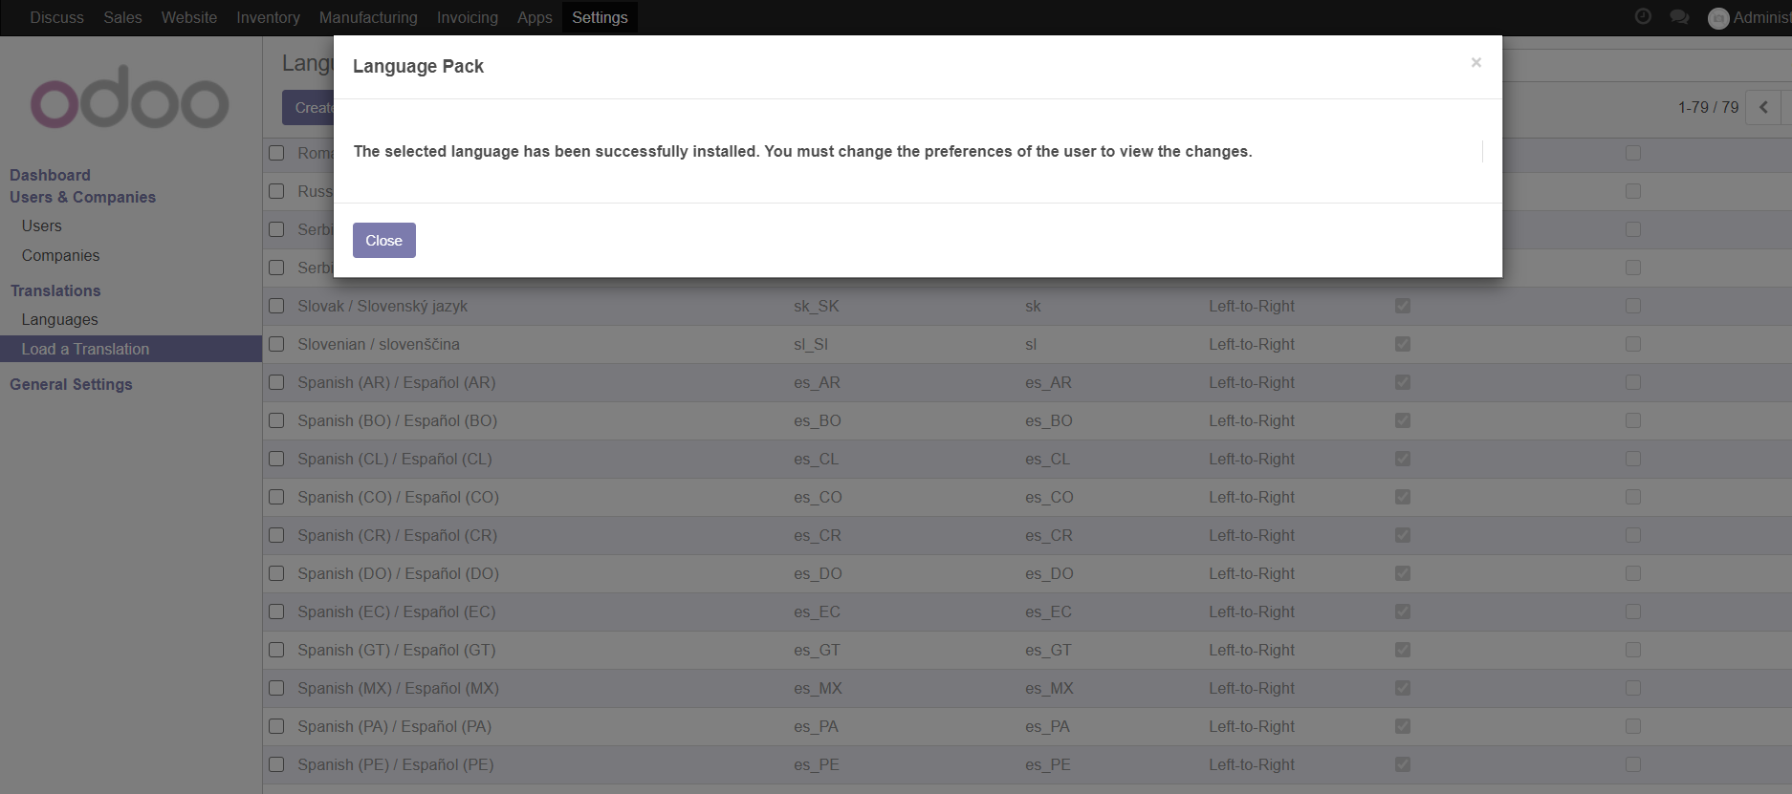

Figure 34 - Added language confirmation

After successfully loading a language, we can go to preferences and change our language and time zone to our preferred ones.

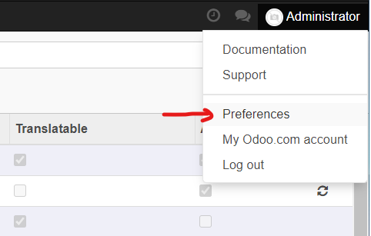

Figure 35 - Preference selection

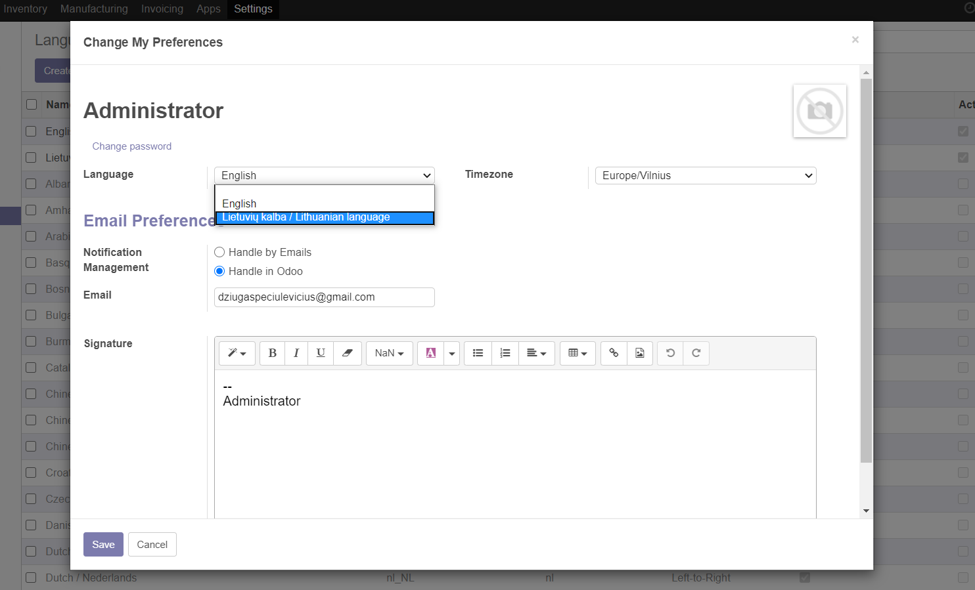

Figure 36 - Changing preference language

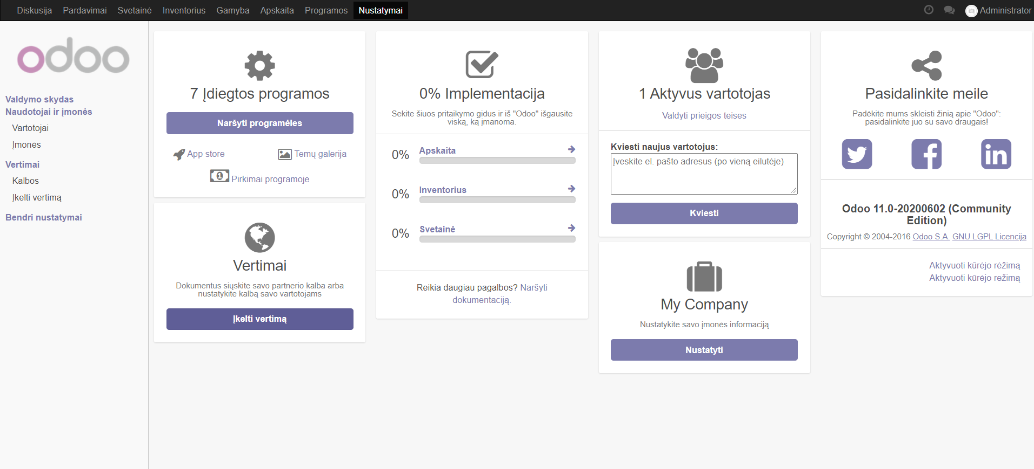

Figure 37 - Setting page

And there we go. We have a working language. We can do with all the languages that are offered to us by ODOO.

## **Setting currency settings**

Setting a currency is pretty straightforward. All we need to do is go to settings and then go to currencies. Then we can select to have more than one currency and we are done.

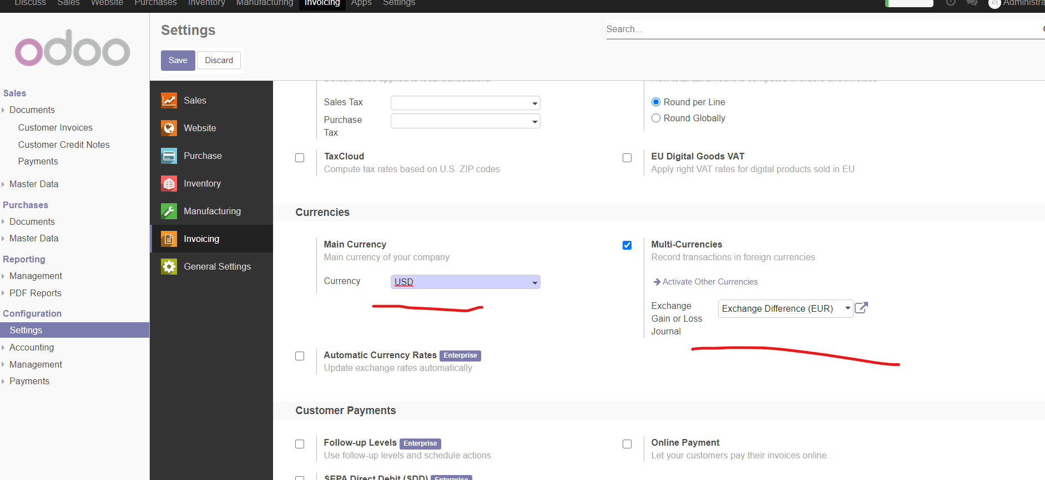

Figure 38- Setting currency

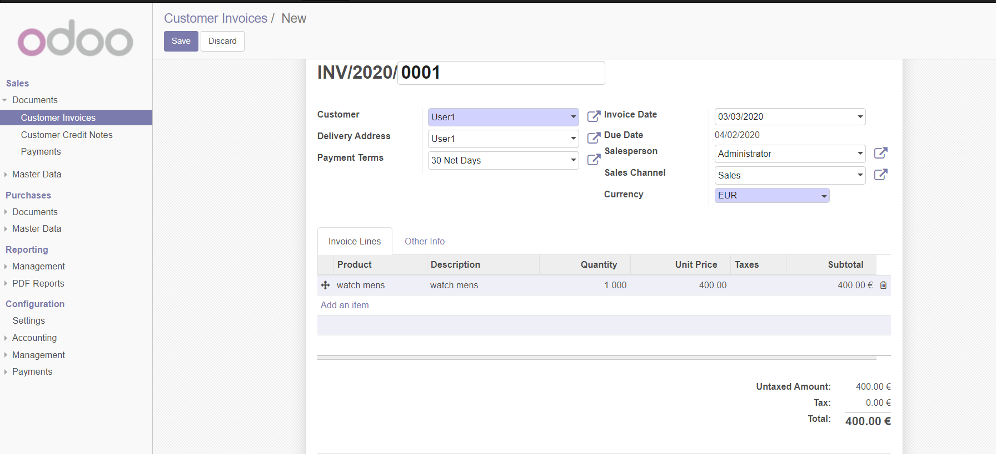

Figure 39- Can now change currencies

## **Setting rules**

Here we can set all the rules, that we don’t want users to do. For example we are limiting here what regular users cannot do compared to the admins, so they would not do anything wrong with the system and things that they don’t have permission to.

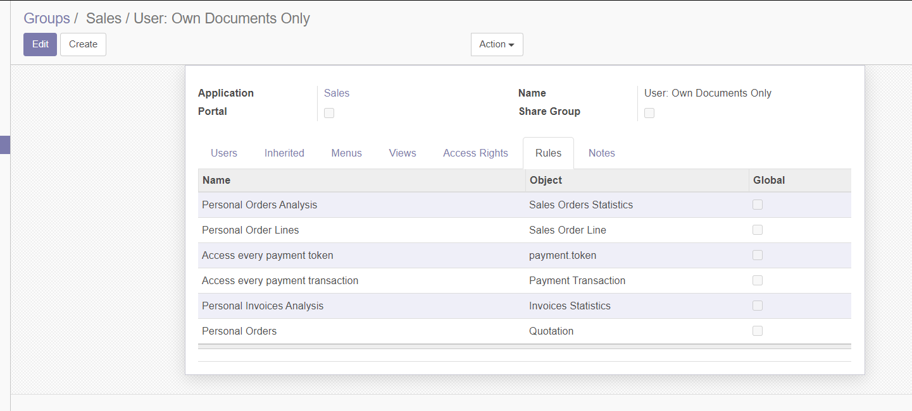

Figure 40 - User specific documents

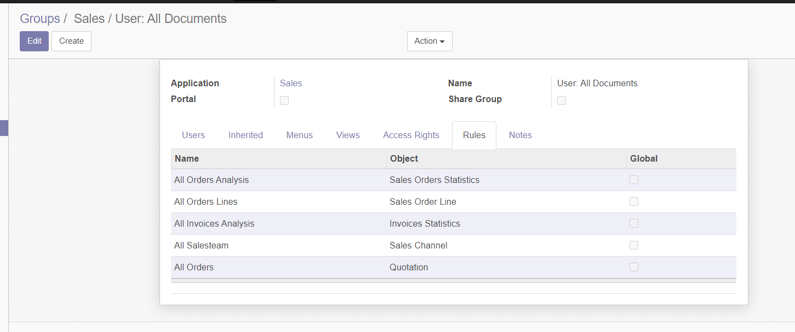

Figure 41 - All user documents

# CONCLUSIONS

# Discussed modules in the work help us build producs, materials, keep track of orders and material numbers and quantity. By using odoo and these modules a business can receive some benefits. It‘s pretty easy to use, it will make a job easier for a business. It will help changing languages, currencies and help with transfering or limiting data to end users.